SEASON EXPEXTATIONs
DIVISION FACTS
- Field Location: Holland Township School
- Field Size: 135’ W x 210’ L
- Goal Size: 7’ x 21’
- Game Format: 9 v 9
- Game Length: 2 – 30-minute halves
- Ball Size: Size 4

Schedule
- Practices: Tuesday and Thursday
- Games: Saturdays

certifications
- Background Check
- Heads-Up Concussion Training

  - DELAWARE VALLEY YOUTH SOCCER CLUB

U12 DIVISION FACT SHEET
What is expected of you as a Volunteer Parent Coach?
Our volunteer coaches are responsible for their team and making sure that all players, parents and coaches abide by the roles and responsibilities laid out in DVYSC By-Laws. You are the face of our organization!

PARENT COMMUNICATION
Communicate with your Parents on a constant basis
Communicate with the parents of your players on a continuous basis. Send out weekly reminders for practices and games. Consider having a team meeting with your parents in the beginning of the season to lay out expectations.
The “Game Changer” App that is connected to our website is available (or use TeamSnap) to help facilitate communications.

Practices
Plan ahead, keep your Players Moving, Have Fun!
DVYSC has provided you with a lesson plan for the season. Please feel free to use this lesson plan or use is it as a guide to develop you practice plan. Please keep in mind that we are following US Soccer Player Development Model and at this age we are at the “Us” stage in development. DVYSC is here to assist you, if you need help or have a question on a drill please ask!

Game Day responsibilities
What is expected of you on game days?
Please ensure that there are two coaches on the sidelines during games, this is a requirement of DVYSC. Coaches are not allowed to cancel games for any reason without the approval of the DVYSC President. If there is inclement weather the home team (DVYSC Board) is responsible for checking the fields and determining if they are playable. When arriving at the field please place the corner flags at your assigned field and remove them if you are the last game at that field. Game balls are located in the Field Shed.
Please report your scores to the President on the same day as the game was played.
RECOMMENDED FORMATIONS
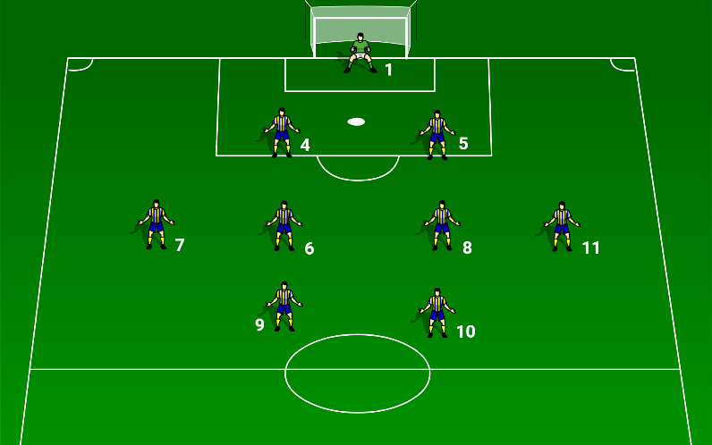 | Formation: 2 – 4 – 2  Benefits:  - Strong midfield  - Good for possession type play  Drawbacks:  - Defense vulnerable to 1v1  - Outside midfielders need to cover a lot of ground.
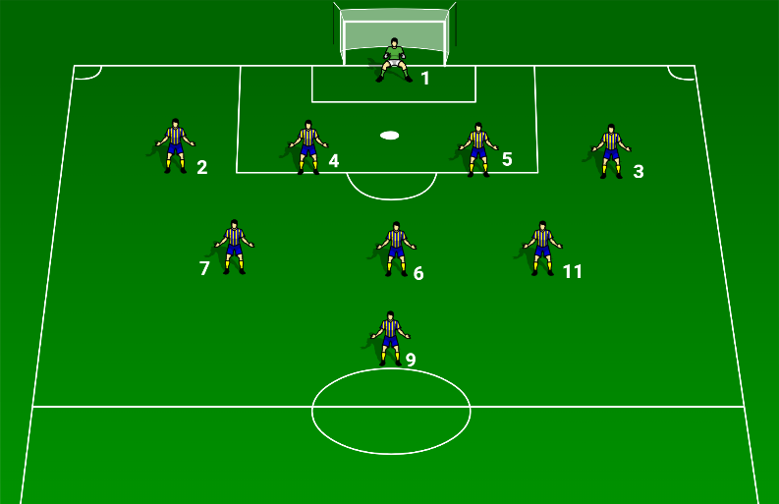 | Formation: 4 – 3 – 1  Benefits:  - Defensive  - Expansive  Drawbacks:  - Need to hold formation  - Outside midfielders need to cover a lot of ground.
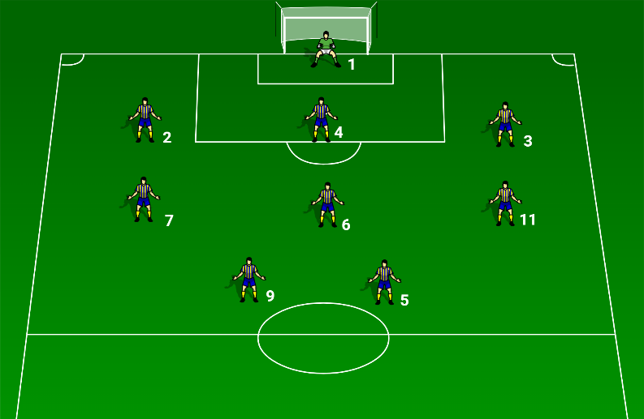 | Formation: 3 – 3 – 2  Benefits:  - Offensive  - Several lines of support  Drawbacks:  - Outside players need to support the center forwards  - Defenders do not support the attack
U12 DIVISION FACT SHEET
DELAWARE VALLEY YOUTH SOCCER CLUB

